Archives
Sir Francis Ronalds (1788-1873)
Meterologist, inventor and pioneer of electric telegraphy.
Francis Ronalds was born in 1788, the second of eleven children. When he was nineteen his father died and Francis, with his mother, was expected to run the family cheesemonger business. He combined this with an interest in chemical experiments and in 1814 was encouraged by Jean André de Luc to start work on electricity. In the best traditions of nineteenth century scientists, these experiments were carried out at home and by 1816 there was a working telegraph in the garden, designed and built by Ronalds himself.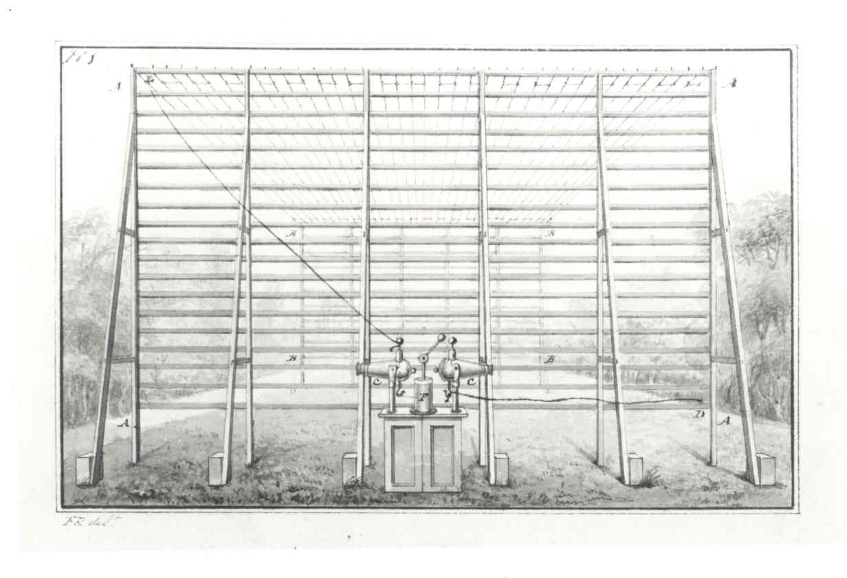
This telegraph consisted of a single wire encased in glass tubing, which was then placed in a wooden trough in a trench filled with earth. The wire was kept charged using a friction machine. At each end, clockwork dials were used to indicate the letter or figure being transmitted. It was slow, but it worked.
Ronalds never patented his invention but offered it to the Admiralty for government use. The Admiralty were not interested. They saw telegraphy as 'wholly unnecessary' and couldn't see how it could be more useful than semaphore. One person did benefit from this work - Charles Wheatstone. He saw the telegraph as a boy, and later patented the first working electric telegraph with William Cooke.
After this disappointment, Ronalds set off for the continent. He travelled throughout Europe and the Eastern Mediterranean, taking notes, sketching and collecting scientific books. The last activity formed the beginnings of the Ronalds Library, left in trust to the Institution after his death.
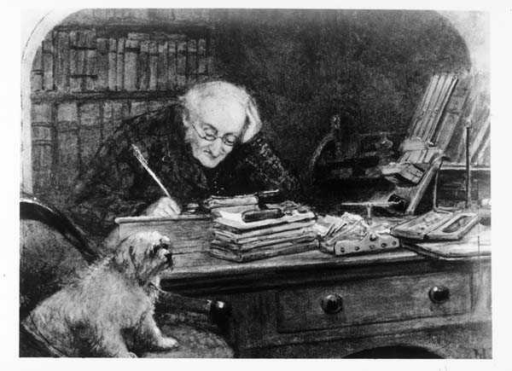
In 1843, Ronalds was appointed the first Honorary Director and Superintendent of the Observatory at Kew. He began work on a system for registering meteorological data using photography and this time was awarded a grant to continue his work. A similar system was developed independently by Charles Brooke, but the British Association confirmed Ronalds' priority. This was the beginning of automatic, accurate recording of meteorological data and remained in use for some years after Ronalds' death.
Ronalds retired in 1852 and was awarded a pension of £75 a year in recognition of his services to meteorology and electricity. He used this money to add to his library, which had reached 1500 books and 5000 pamphlets when he died. Many of his later years were spent cataloguing his collection and adding records of other scientific books which had been published on electricity and magnetism. Ronalds died in 1873, but not before he had been knighted in recognition of his 'early and remarkable labours in telegraph investigations'.
To find out more about Ronald's Telegraph please see our article in the Feature's section or our Research Guide on Telegraphy for more information on what sources we have in the Archives.

